Shenzhen University

Report of The Experiments

Course： Information Security and Blockchain

Topic： Ethereum and Smartcontract

Class： 22文华班

StudentID： 2022280297

Name： 陈应权

Date： 2024年12月22日 星期日

Score：

1. Experiment Content
1) Write a simple smart contract, simulate deploying it and calling it.

2) (Optional) Write a simple, smart contract for issuing your own ERC20 tokens (name your own token names), and deploy it to the ethereum test network, and perform a transfer demonstration.

2. The experimental code and results screenshots

1)basic experiment
The first problem is to write smart contracts and deploy them through the web version of the Remix IDE.
The experimental code(a simple smart contract):

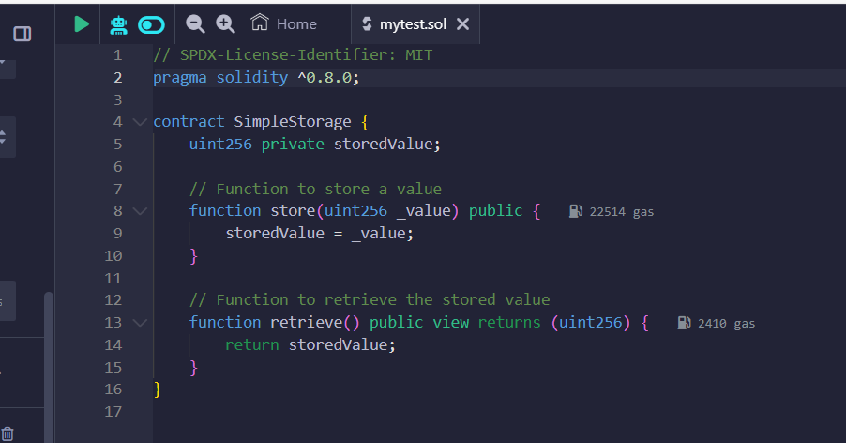
Fig. 1 The experimental code (a simple smart contract)

Step 1: Write the Simple Smart Contract (Solidity)
We’ll create a smart contract that stores and retrieves a value. This contract has two functions:
- store(uint256 _value) to store a value.
- retrieve() to retrieve the stored value.

Step 2: Simulate Deployment and Interaction Using Remix IDE

Results:

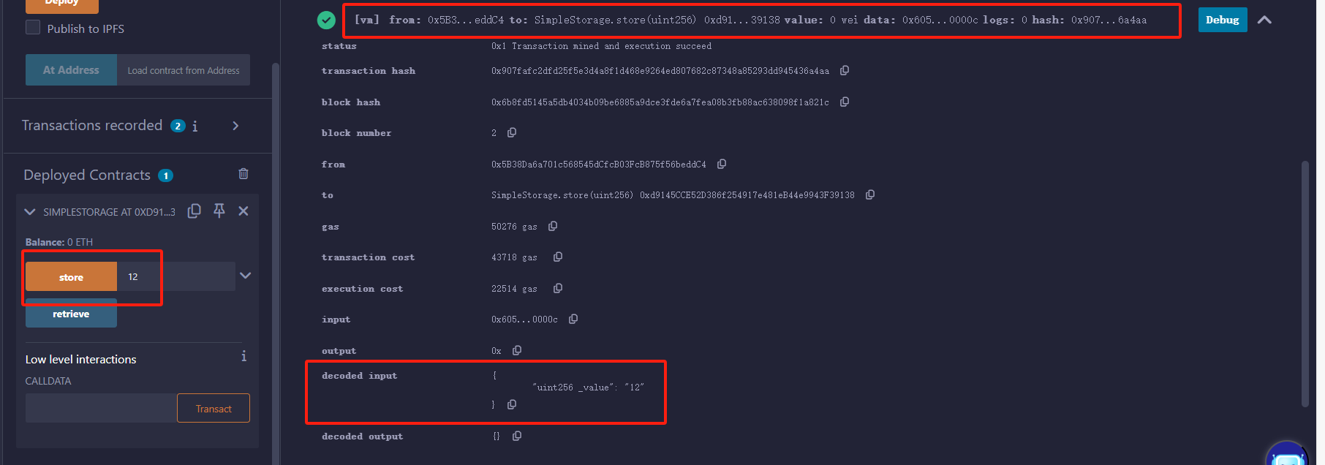
Fig. 2 The output interface after storing the number 12

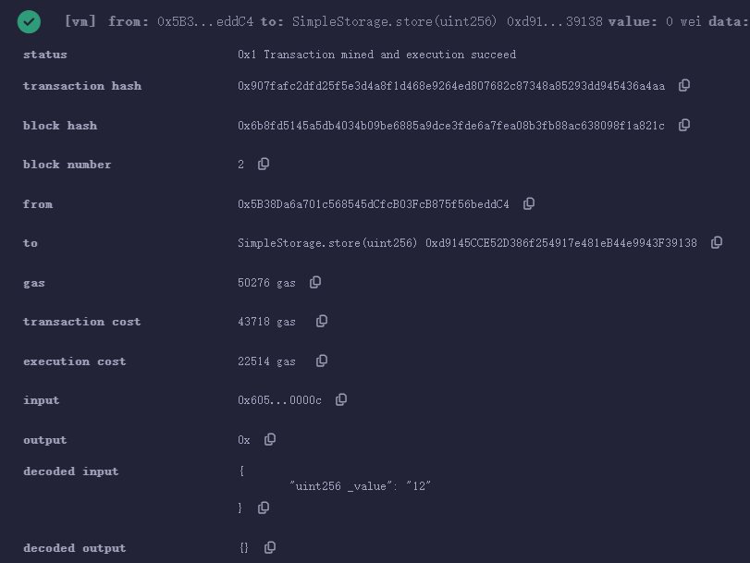
Fig. 3 The output interface after storing the number 12 (partial enlarged drawing)

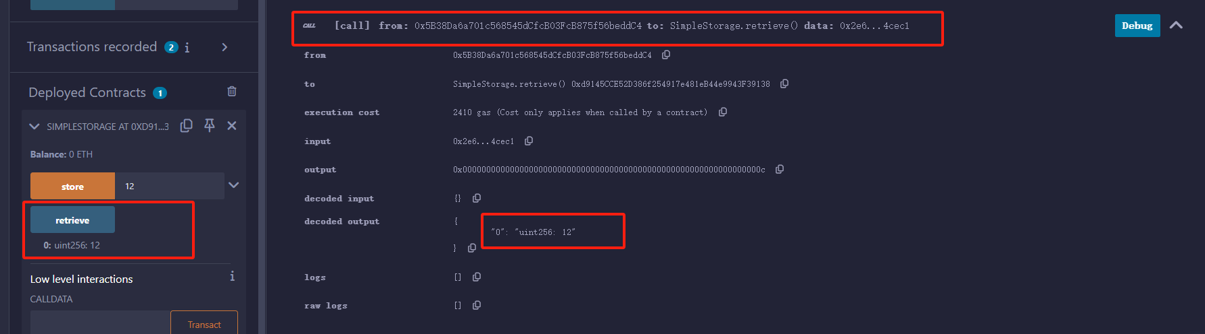
Fig. 4 The output interface after retrieve the value
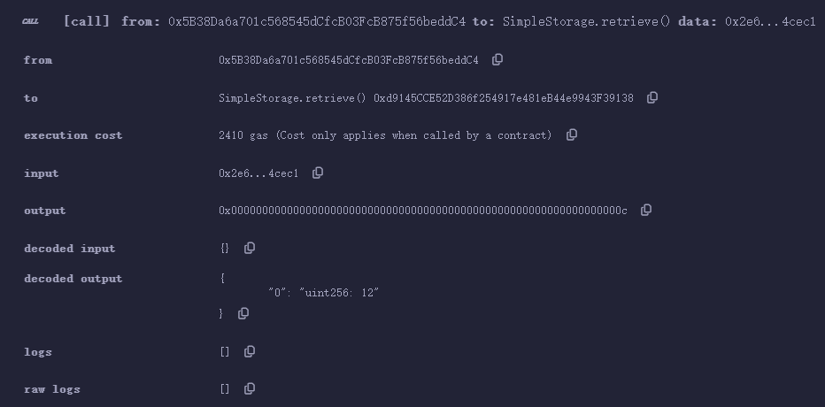
Fig. 5 The output interface after retrieve the value(partial enlarged drawing)
This problem focuses on writing, deploying, and interacting with a very simple smart contract. Finally, a contract for storing and retrieving values is implemented.
The specific experimental steps are as follows:

1. Open Remix IDE
Go to Remix IDE.

2. Create a New File
- In the Remix IDE, click on the File Explorer tab on the left side.
- Click the New File button.
- Name the file SimpleStorage.sol.

3. Paste the Smart Contract Code
Copy and paste the smart contract code from above into your SimpleStorage.sol file.

4. Compile the Contract
- Click on the Solidity Compiler tab on the left sidebar.
- Select the correct compiler version (the latest version that is compatible with your code, e.g., 0.8.0).
- Click Compile SimpleStorage.sol.

5. Deploy the Contract
- Go to the Deploy & Run Transactions tab.
- Select the Environment to use the JavaScript VM (this is an in-memory Ethereum network for testing).
- Click Deploy.
The contract will be deployed, and you'll see a transaction log in the console at the bottom.

6. Interact with the Contract
- Once the contract is deployed, you’ll see the contract instance appear under Deployed Contracts.
- There are two functions available:
  - store(uint256 _value): To store a value.
  - retrieve(): To retrieve the stored value.

0Example of Storing and Retrieving a Value:
- Store a Value:
  - In the store function, enter a value, for example, 12, and click transact.
  - This will execute the transaction and store the value 12 in the contract.
- Retrieve the Stored Value:
  - Click on the retrieve function, and it will return 12, the value you just stored.

2)Optional experiment:
The key to this optional problem is to deploy our smart contract to a test network and view the results of the transaction information. There are many options for testing the net, and here I mainly talk about how I did it.
- The first is to create a MetaMask account, then switch the network to the test network, in this case I chose Sepolia.
- Then go back to the Remix deployment contract and choose to connect to MetaMask at deployment time.
- Sepolia's test currency is available for free via the tap, as detailed in the article below.
MetaMask安装及使用（全网最全！！！）-CSDN博客
However, I have tried to obtain four faucets, all of which require a certain ETH on the main network to comply with the rules of receiving, so I can only go to Taobao to buy test ETH, as shown in the following figure ,from https://sepolia.etherscan.io/
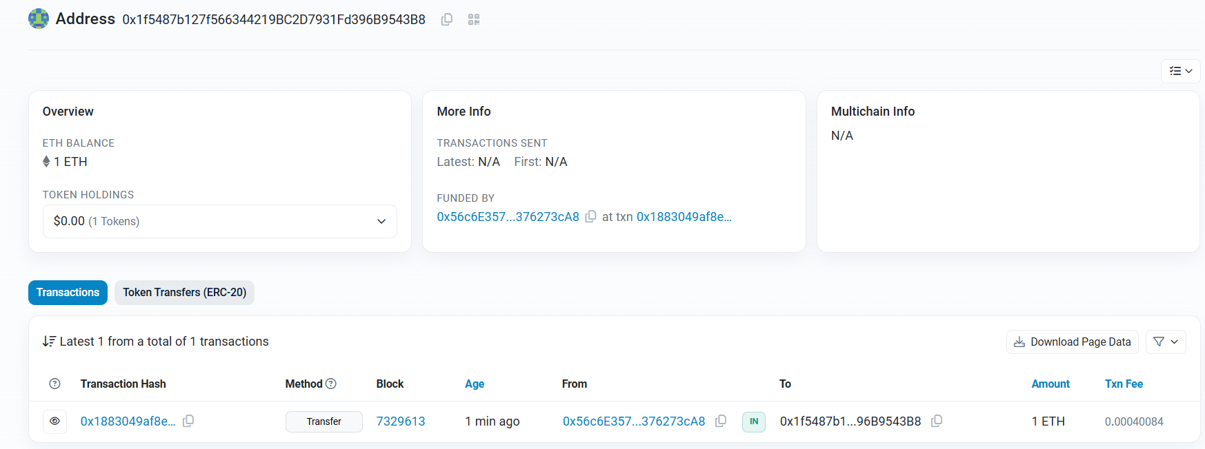
Fig. 6 a record of a purchase just made
The experiment can then be officially started, showing the token contract and the results:
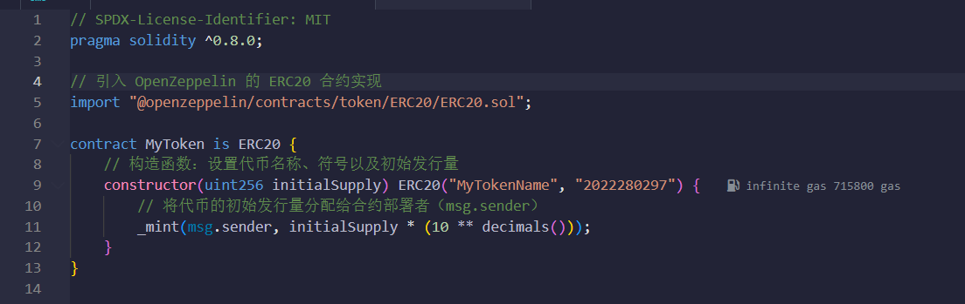
Fig. 7 A simple EPC20 token contract code

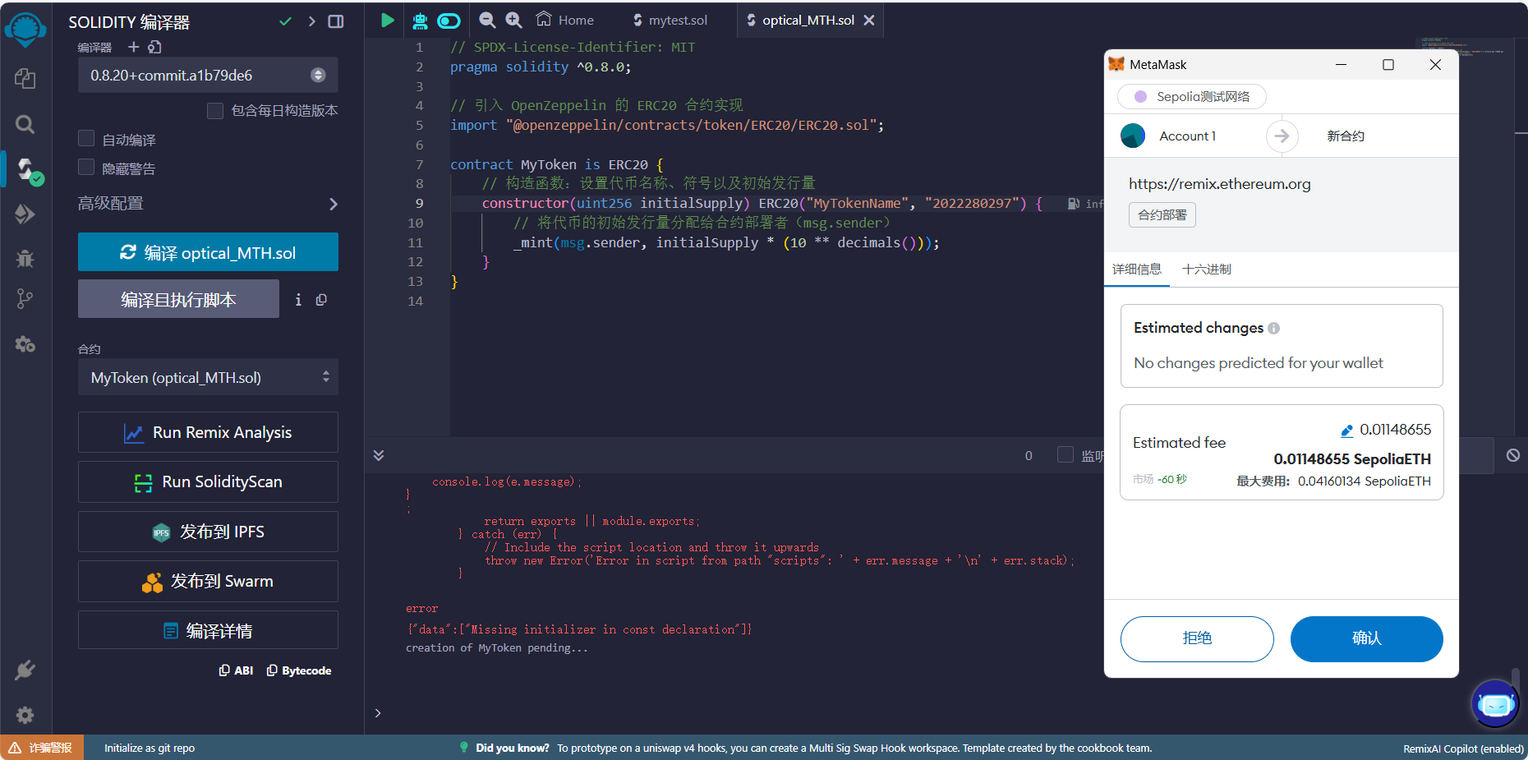
Fig. 8 Test ETH tokens are required when the contract is deployed on the test network

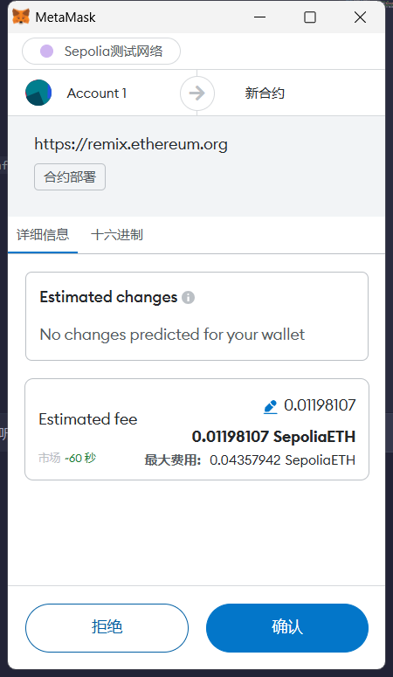
Fig. 9 The payment order pops up
You can see it displayed in the sepolia test net, along with my account address as I showed earlier.
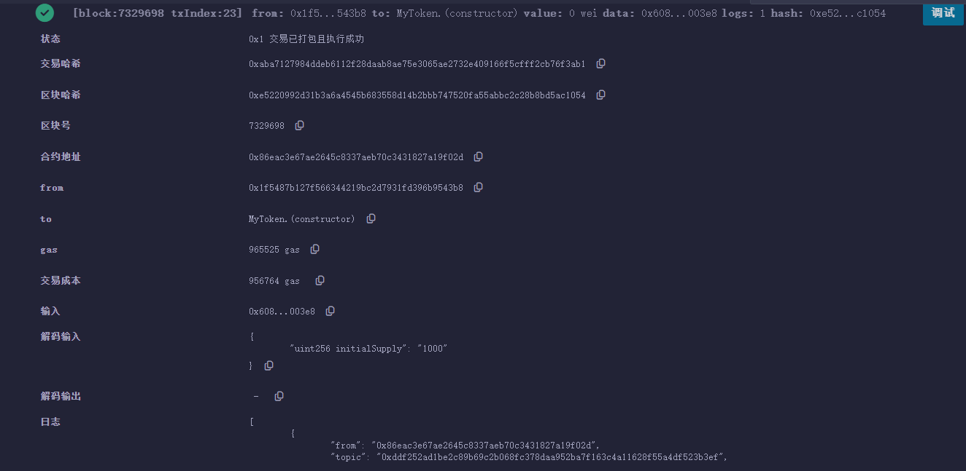
Fig. 10 You can see a history of successful deployments on the Remix IDE
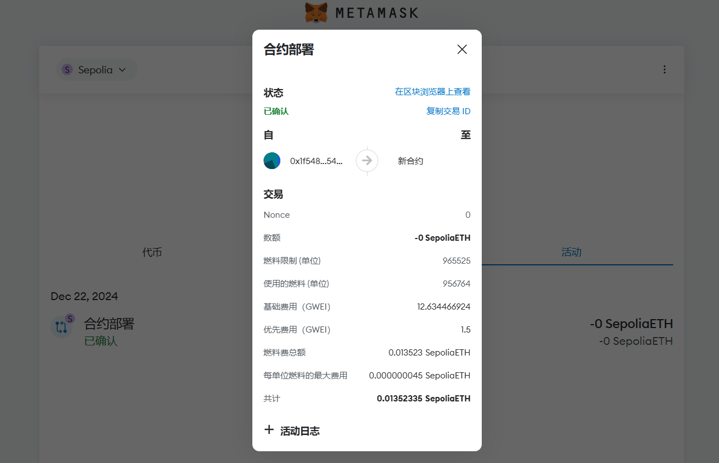
Fig. 11 You can see a history of successful deployments on the MetaMask

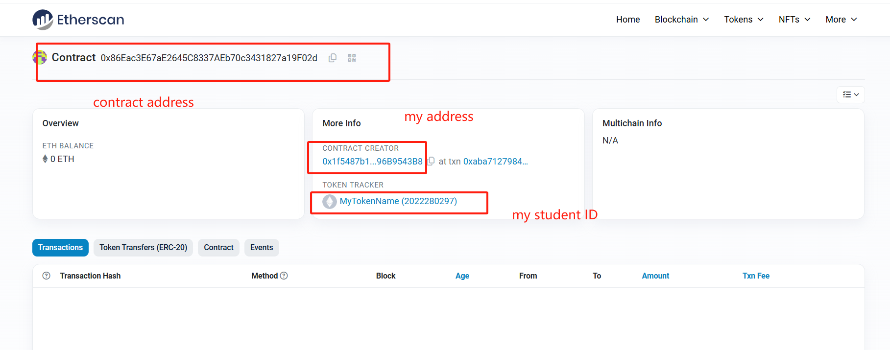
Fig. 12 In addition, the contract we just published can be viewed on Etherscan
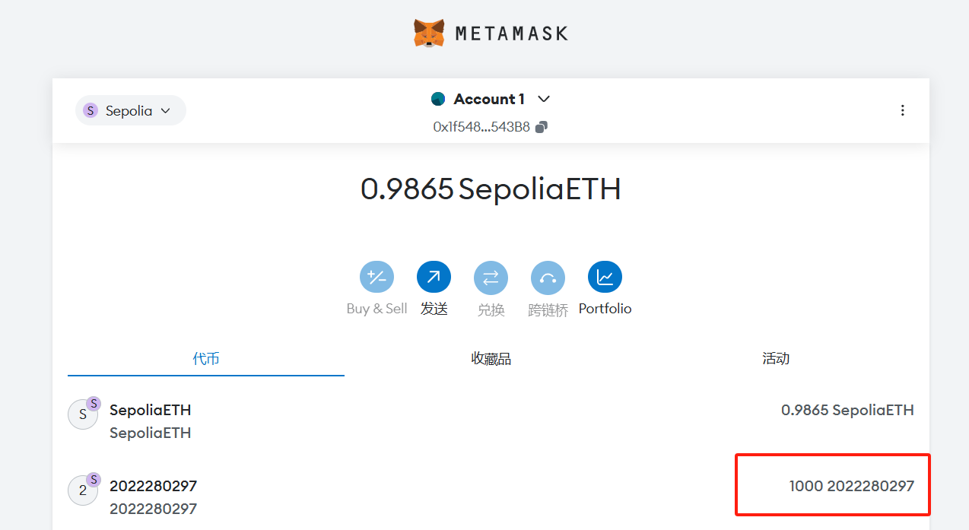
Fig. 13 Add the token I just created to MetaMask at my first account

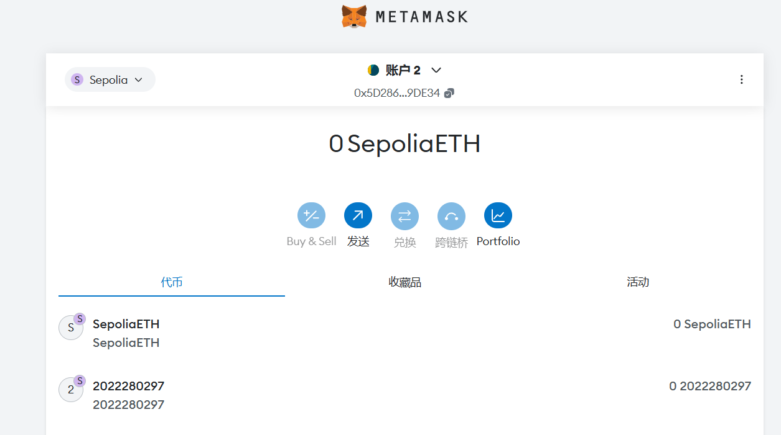
Fig. 14 Add the token I just created to MetaMask at my second account

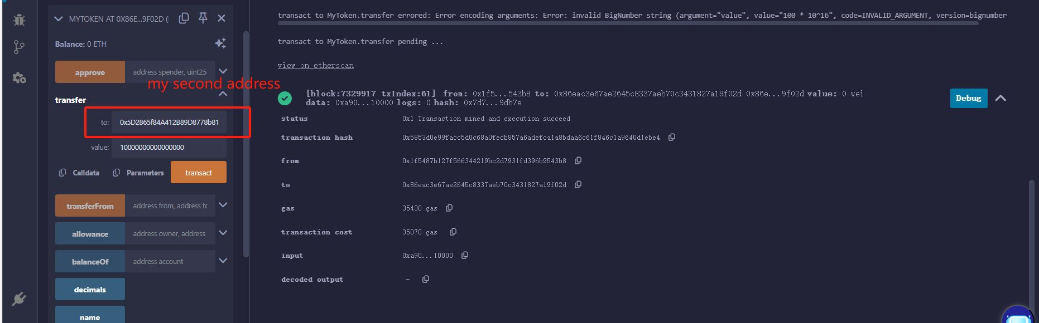
Fig. 15 Go back to Remix IDE to trade
Here I transfer 0.01 tokens of 2022280297 to my account 2.
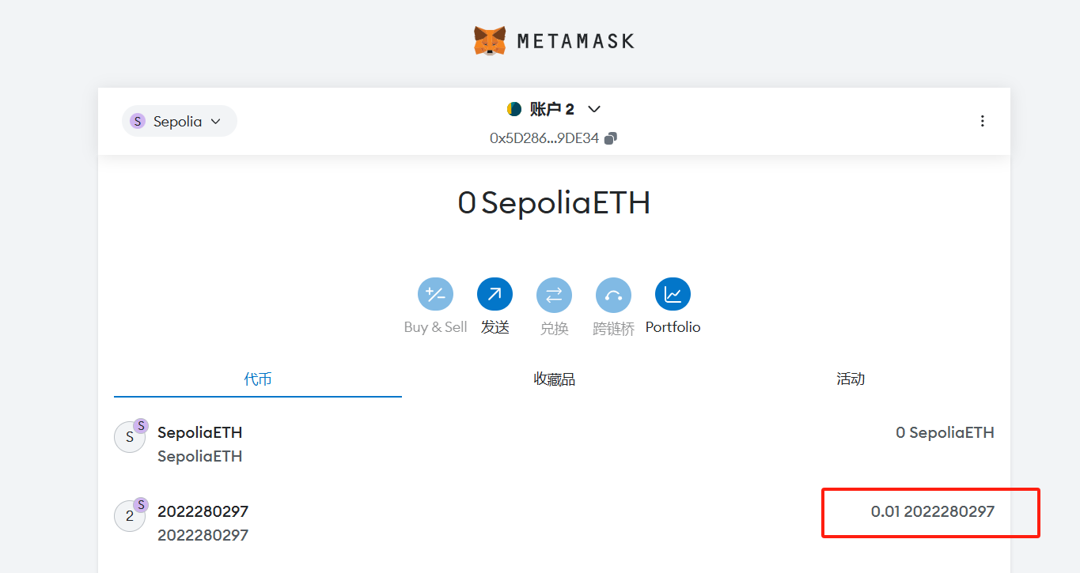
Fig. 16 You can see that the token value of my account 2 in MetaMask goes up to 0.01

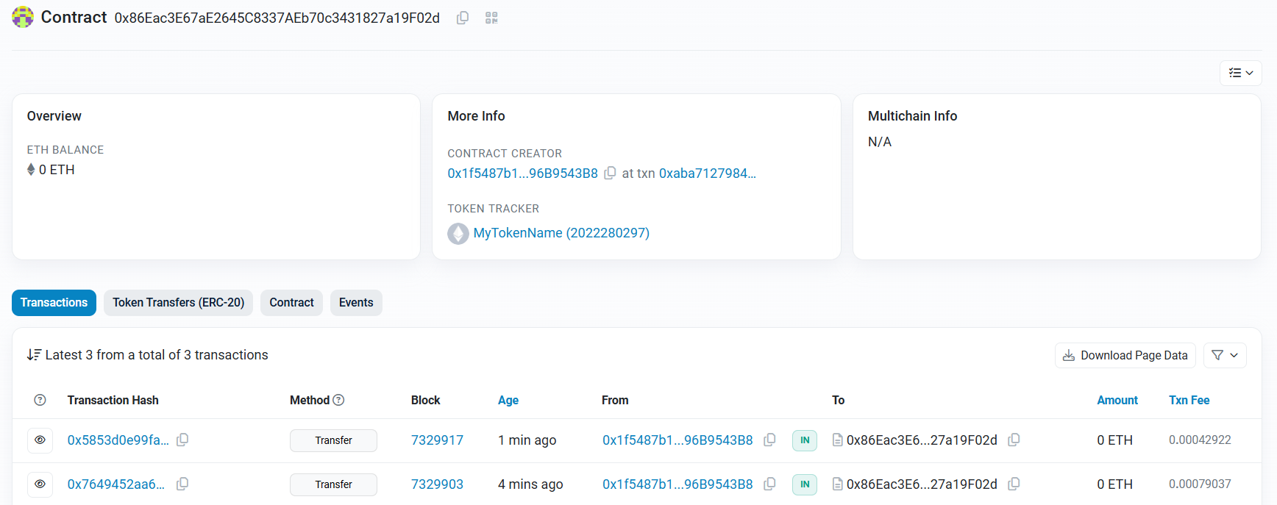
Fig. 17 Finally, you can go to Etherscan to see how many trades have been made on the contract

At this point, I completed the deployment of a simple EPC20 token contract, deployed it in the Sepolia test network, and finally made a transaction between my two accounts, and I completed all the requirements of the experiment by using Etherscan to view the record in real time.

Here I would like to share the contract address of the token named after my student number:

0x86Eac3E67aE2645C8337AEb70c3431827a19F02d

The more difficult point of this experiment is that when you just contact this smart contract, you need to find the corresponding editing website or software, then register MetaMask and get familiar with its use, and then obtain the test ETH of this test network Sepolia. Many taps cannot be opened to novices. Finally, there are some difficulties in deploying the transaction environment, and solving these problems has allowed me to gain a lot, and also have a certain understanding of deploying a own token contract and trading.

